**R-2.8**

Running Time

22 15 26 44 10 3 9 13 29 25 10 {insertion of 10 items in unsorted sequence}

3 15 26 44 10 22 9 13 29 25 9 {comparisons are needed}

3 9 26 44 10 22 15 13 29 25 8

3 9 10 44 26 22 15 13 29 25 7

3 9 10 13 26 22 15 44 29 25 6

3 9 10 13 15 22 26 44 29 25 5

3 9 10 13 15 22 25 44 29 26 4

3 9 10 13 15 22 25 26 29 44 3

3 9 10 13 15 22 25 26 29 44 1

Total running time = 53

**R-2.9**

22 15 26 44 10 3 9 13 29 25 10

15 22 26 44 10 3 9 13 29 25 1

15 22 26 44 10 3 9 13 29 25 1

15 22 26 44 10 3 9 13 29 25 1

10 15 22 26 44 3 9 13 29 25 8 {4 swaps + 4 comparisons}

3 10 15 22 26 44 9 13 29 25 10

3 9 10 15 22 26 44 13 29 25 10

3 9 10 13 15 22 26 44 29 25 2

3 9 10 13 15 22 26 29 44 25 6

3 9 10 13 15 22 25 26 29 44 0

Total running time = 49

**R-2.10**

4 3 2 1 4 {4 insertions}

3 4 2 1 2 {1 comparison + 1 swap}

2 3 4 1 4 {2 comparisons + 2 swaps}

1 2 3 4 6

Total running time = 16

Any array sorted in descending order should have Ω(n2) running time

**R-2.13**

Since the items in the vector are sorted, then the key of any item will be greater than or equal to its parent. As a consequence, tree T is a heap.

**R-2-18**

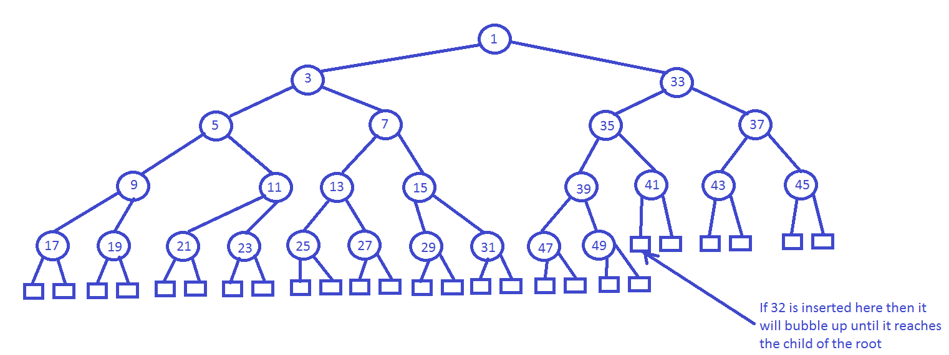

**C-2.32**

**Algorithm** reportSmallerKeys(H, x)

s 🡨 create new sequence

i 🡨 1

while i <= H.size() ∧ H[i] <= x do

s.insertLast(H[i])

i 🡨 i +1

return s